**Calculator Assumed**

**Applications of Anti-Differentiation 2**

Time: 45 minutes

Total Marks: 45

Your Score: / 45



**Question One: [6 marks] CA**

Calculate the shaded area shown below, showing all relevant working.

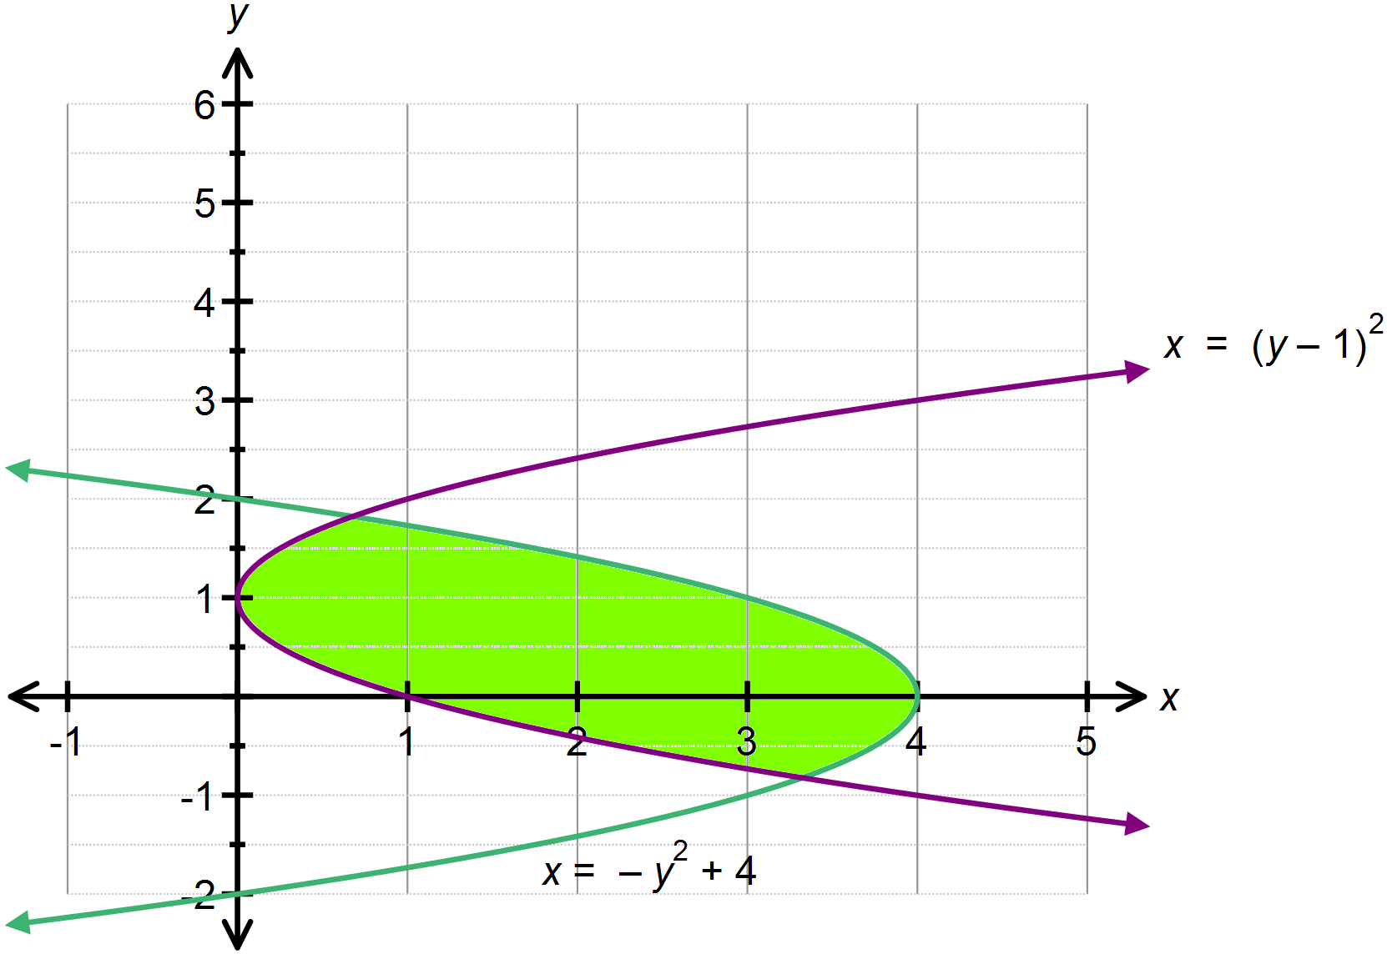

**Question Two: [1, 1, 2, 3, 2, 3, 2, 5 = 19 marks] CA**

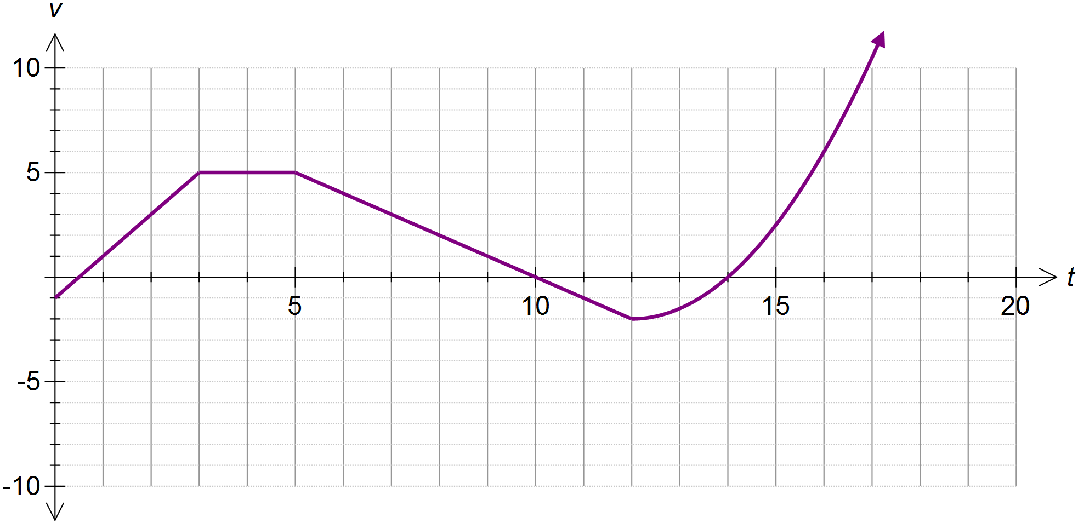A particle moving in rectilinear motion has its velocity function graphed below, where *t* is time in seconds and *v* is in ms-1.

(a) Determine the initial speed of the particle.

(b) Determine the acceleration of the particle during the 4th second.

(c) Calculate the displacement of the particle after 3 seconds.

(d) Calculate the distance travelled by the particle in the first 12 seconds.

(e) Determine when the particle has travelled a distance of 21 m since commencement.

(f) State the times when the particle was at rest.

(g) When did the particle first return to the origin?

(h) Calculate the distance travelled by the particle for  if it is known that the velocity for is given by .

**Question Three: [6, 3 = 9 marks] CA**

Sybil has invested $*A* in a fund which compounds her investment continuously at a rate of *k*% per annum.

The rate of change of her investment is given by  where *V* is the value of her investment in dollars and *t* is the time in years.

The net change in the value of her investment in the first 10 years is $12 331 . 78.

The net change in the value of her investment in the next 10 years is $22 469 . 97.

1. Determine the values of *A* and *k*.
2. Hence determine the function that defines the value of her investment.

**Question Four: [2, 2, 3, 4 = 11] CA**

We can use integration to determine the arc length of a curve. The development of this idea is similar to developing the idea of the area under a curve as the sum of infinitely many rectangles, but instead is built on the use of Pythagoras’ Theorem for smaller and smaller right triangles.

The arc length of a section of curve,  is given by:



Consider the function 

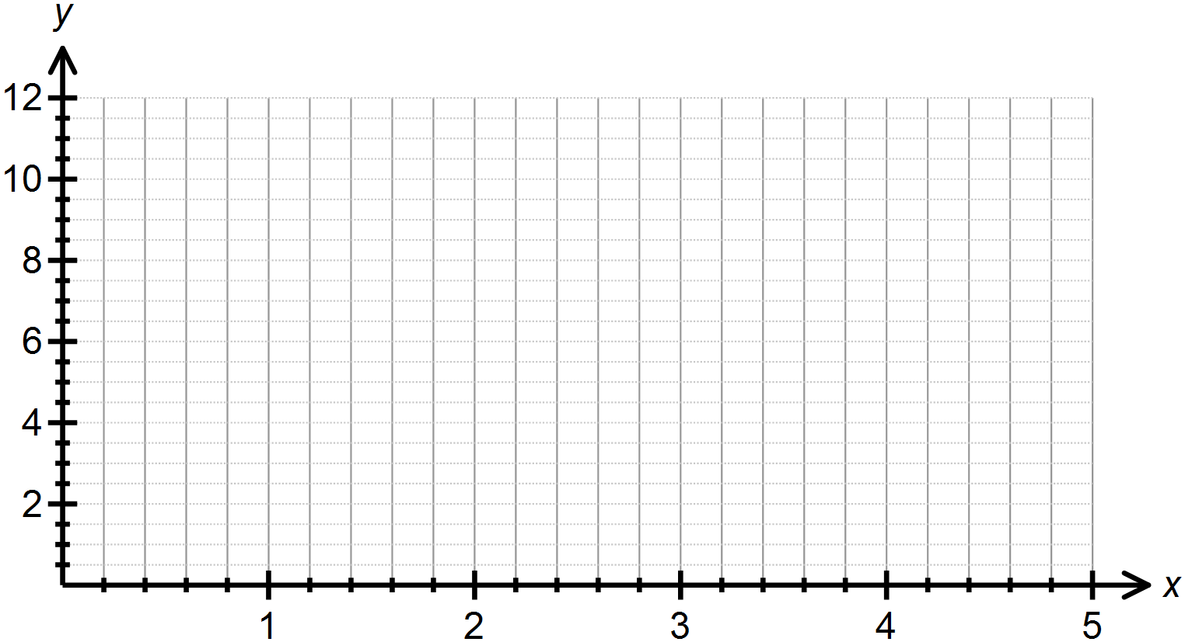(a) Graph this function over the domain  on the graph below.

(b) Use Pythagoras’ Theorem to determine the length of the line drawn above.

(c) Use the arc length formula provided above to confirm that you obtain the same answer as in part (b).

Consider the function  .

(d) Calculate the length of the curve of  over the domain 

**SOLUTIONS**

**Calculator Assumed**

**Applications of Anti-Differentiation 2**

Time: 45 minutes

Total Marks: 45

Your Score: / 45



**Question One: [6 marks] CA**

Calculate the shaded area shown below, showing all relevant working.







**Question Two: [1, 1, 2, 3, 2, 3, 2, 5 = 19 marks] CA**

A particle moving in rectilinear motion has its velocity function graphed below, where *t* is time in seconds and *v* is in ms-1.

(a) Determine the initial speed of the particle.

 

(b) Determine the acceleration of the particle during the 4th second.

Slope of the line between t =3 and t =4 is 0. Therefore 

(c) Calculate the displacement of the particle after 3 seconds.

 

(d) Calculate the distance travelled by the particle in the first 12 seconds.

 

(e) Determine when the particle has travelled a distance of 21 m since commencement.

Distance in first 5 seconds: 16.5m

 Distance in the 6th second: 4.5 m

Therefore 6 seconds.

(f) State the times when the particle was at rest.

 

(g) When did the particle first return to the origin?

 

(h) Calculate the distance travelled by the particle for  if it is known that the velocity for is given by .

 

**Question Three: [6, 3 = 9 marks] CA**

Sybil has invested $*A* in a fund which compounds her investment continuously at a rate of *k*% per annum.

The rate of change of her investment is given by  where *V* is the value of her investment in dollars and *t* is the time in years.

The net change in the value of her investment in the first 10 years is $12 331 . 78.

The net change in the value of her investment in the next 10 years is $22 469 . 97.

1. Determine the values of *A* and *k*.



1. Hence determine the function that defines the value of her investment.



**Question Four: [2, 2, 3, 4 = 11] CA**

We can use integration to determine the arc length of a curve. The development of this idea is similar to developing the idea of the area under a curve as the sum of infinitely many rectangles, but instead is built on the use of Pythagoras’ Theorem for smaller and smaller right triangles.

The arc length of a section of curve,  is given by:



Consider the function 

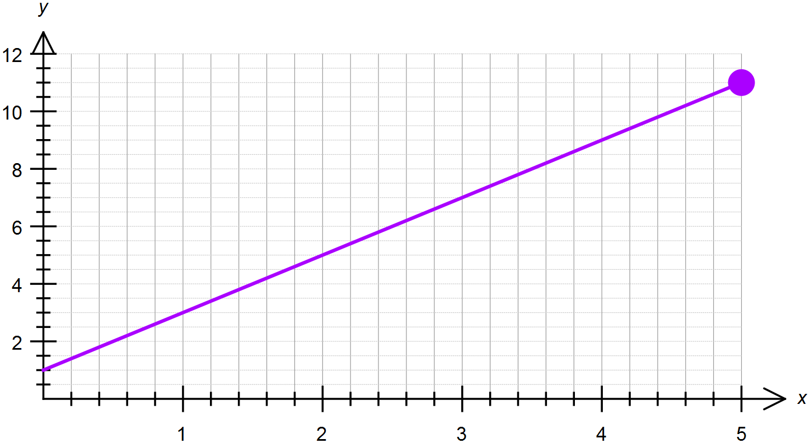(a) Graph this function over the domain  on the graph below.





(b) Use Pythagoras’ Theorem to determine the length of the line drawn above.

 

(c) Use the arc length formula provided above to confirm that you obtain the same answer as in part (b).

 

Consider the function  .

(d) Calculate the length of the curve of  over the domain 

